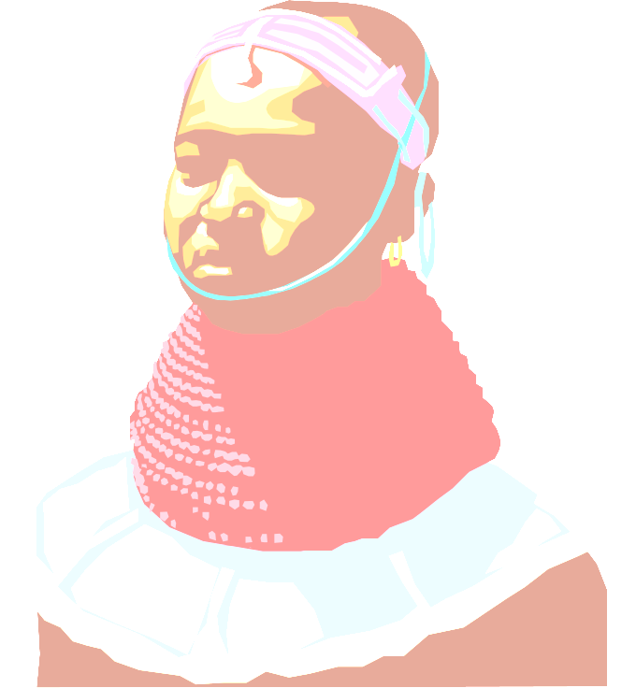
Proceeds will benefit Scholarships for Students with HIV/AIDS and African-American Student Union
For reservations and info call Tekeshia K. Howden at (954) 588-1839 or Devin T. RobinsonX at (754) 246-6907 or
Where: FAU Davie Campus LA Auditorium 120
2912 College Avenue; Davie, FL 33314

When: Dec. 11th 6-10:45p.m

What: Spoken Word Competition for up to 500$
10$ per applicant/ per theme
Themes: AIDS, Kwanzaa, Open and Teen Comp

Cost: 3$ presale w/raffle or 5$ General and 7$ V.I.P

Proceeds will benefit Scholarships for Students with HIV/AIDS and African-American Student Union

For reservations and info call Tekeshia K. Howden at (954) 588-1839 or Devin T. RobinsonX at (754) 246-6907

